SIMATS ENGINEERING
ASSESSMENT TOOL 2: Problem Solving Assignment
COURSE NAME: ARTIFICIAL INTELLIGENCE COURSE CODE: MLA0104
AND EXPERT SYSTEMS

COURSE OUTCOME COVERED
CO2: Analyze and select appropriate agent strategies for different types of environments and problem settings. (BTL 3)
Assessment Tool Weightage: 40 %

Total Marks: 100 Time: 60 Mins
No. of Questions: 5
Annexure A
Problem Solving Assignment

Code of Conduct:

I __K.Nagapreetham(192525242) (Name / Reg No) certify that this submission is my original work and that I have adhered to the guidelines specified for this assessment. I understand that any violation of academic integrity rules will result in disciplinary action.

Signature of the student:
Criterion | Weightage | Marks Obtained
Problem Analysis and Understanding | 15%
AI Algorithm Selection & Justification | 15%
Algorithm Design / Pseudocode | 25%
Application of AI Concepts (Greedy, A*, CSP,  Minimax, etc.) | 15%
Diagram / State Space / Search Tree  Representation | 10%
Complexity Analysis and Solution Efficiency | 10%
Originality, Critical Thinking, and Presentation | 10%
Total | 100%

Signature of the Faculty Total Marks Awarded

Answer All the Questions
Q.No | Application-Based Question | Major CO2  Concepts
1 | Smart Ambulance Navigation:  An ambulance must travel from a hospital to an emergency location through a city road network. Some roads have higher travel costs, and an estimated distance to the destination is available for each junction. Design a search-based solution to identify the best route. Using the given road network and heuristic values, determine the route selected by your algorithm, show the sequence of junctions explored, calculate the relevant evaluation values, and justify whether the route is optimal.  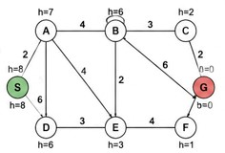 | Informed Search,  A*, Heuristic  Function
2 | Autonomous Warehouse Robot:  A robot has to move from a charging station to a target shelf in a warehouse. The robot does not know all obstacles initially and discovers some obstacles only when it reaches nearby locations. Design an intelligent search strategy for the robot. Demonstrate the robot's decisions for the given grid, explain how it reacts when a new obstacle is discovered, and compare the approach with an offline search strategy.  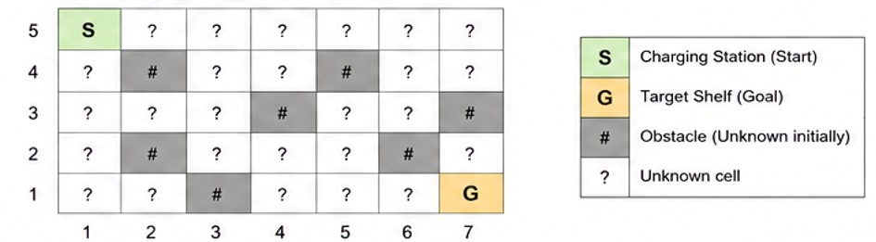 | Online Search  Agents,  Informed Search
3 | University Examination Scheduling:  A university needs to schedule six examinations (E1, E2, E3, E4, E5, and E6) into four available time slots (T1, T2, T3, and T4). Some examinations have common students and therefore cannot be conducted in the same time slot. | CSP, MRV,  Forward  Checking,  Constraints

The following constraints must be satisfied:
- E1 and E2 have common students.
- E1 and E3 have common students.
- E2 and E4 have common students.
- E3 and E5 have common students.
- E4 and E6 have common students.
- E2 and E5 have common students.
The university has three examination halls with the following capacities:

 |  | Examination Hall |  |  |  | Capacity
 |  | Hall A |  |  |  | 120 students
 |  | Hall B |  |  |  | 90 students
 |  | Hall C |  |  |  | 60 students
 |  | Examination | E1 | E2 | E3 | E4 | E5 | E6 | CSP) by  (MRV) timetable.  provide  hall-capacity
 |  | Number of  Students | 100 | 80 | 70 | 60 | 90 | 50
Tasks:
- Formulate the problem as a Constraint Satisfaction Problem ( clearly defining the variables, domains, and constraints.
- Use Backtracking with the Minimum Remaining Values heuristic and Forward Checking to obtain a valid examination
- Show the domain of each variable after every assignment and the final timetable, ensuring that all student-conflict and constraints are satisfied.
4 |  | Game-Playing AI:  You are developing an AI opponent for a board game. The current game position produces the following possible moves and terminal scores in the supplied game tree. Determine the move the AI should make by applying Minimax. Then apply Alpha-Beta Pruning and identify the branches that do not need to be evaluated. Explain how pruning improves the efficiency of the game-playing agent. |  |  |  |  |  |  |  | Game Playing,  Minimax,  Alpha-Beta  Pruning
 | 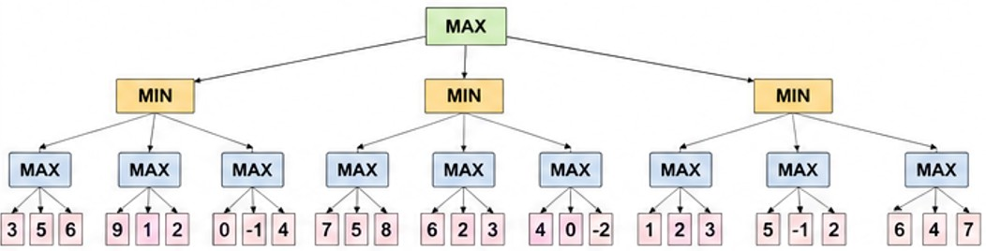
5 | Delivery Route Optimization:  A logistics company wants to minimize the total distance travelled by a delivery vehicle visiting multiple customers. An initial route and several neighboring routes are provided. Design an optimization strategy to improve the route. Apply the strategy step-by-step to the given routes, determine the final route, explain whether it represents a global optimum, and suggest how the algorithm could escape a local optimum.  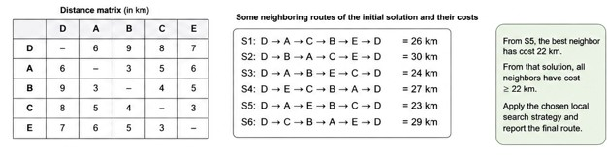 |  |  |  |  |  |  |  |  |  | Local Search,  Optimization,  Hill Climbing

Q1. Smart Ambulance Navigation — A* Search
The ambulance has to travel from a hospital to an emergency location through a road network. Roads have different costs and heuristic estimates are available. Therefore, A* is the appropriate informed-search algorithm.
Step 1: Represent the road network:
Worked example because the actual network is missing from the PDF:

Where:
- H = Hospital
- G = Emergency location
- Numbers = road costs
Heuristic values:
Junction | h(n)
H | 7
A | 6
B | 5
C | 3
D | 2
G | 0

Step 2: A* formula:

Where:
- g(n) = actual cost from H to n
- h(n) = estimated cost from n to G
- f(n) = total estimated cost

Step 3: Start at H:
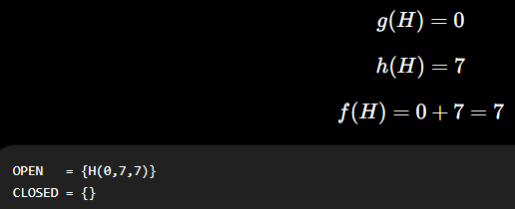
Step 4: Expand H:
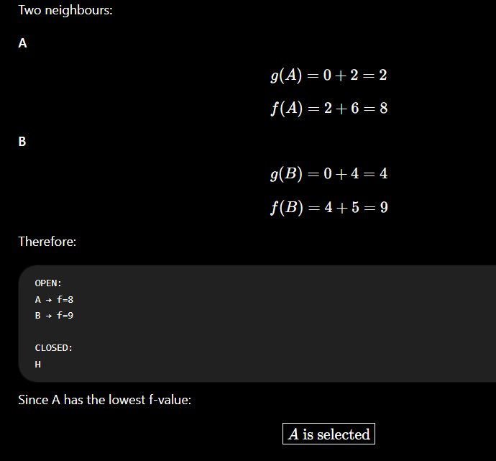
Step 5: Expand A:
A → C has cost 4.
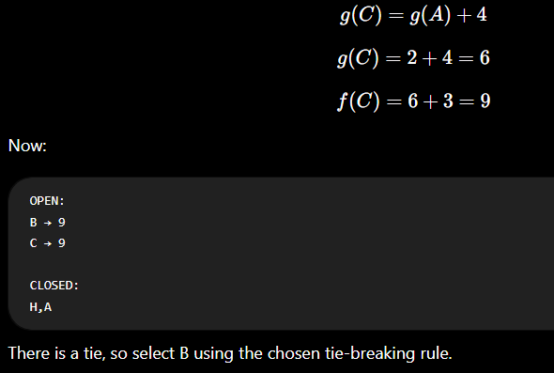

Step 6: Expand B:
B → D has cost 3.
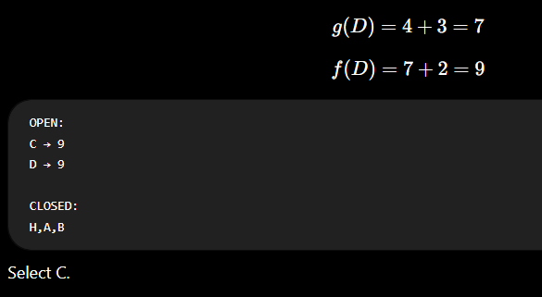

Step 7: Expand C:

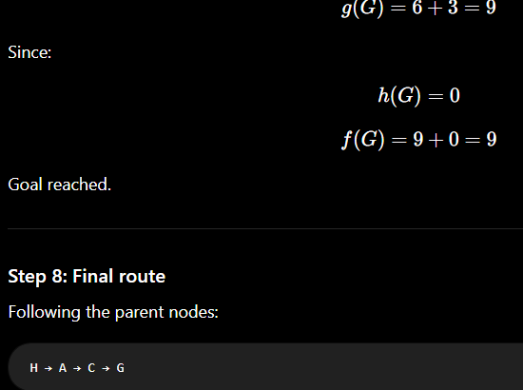
Step 8: Final route:
Following the parent nodes:
H → A → C → G
Therefore:
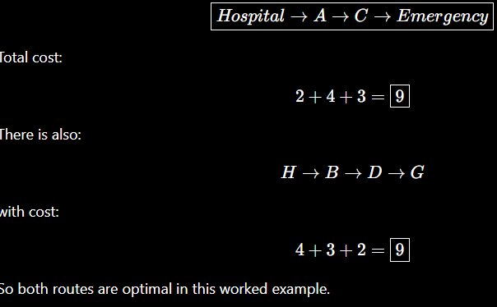

Final A* table:
Node | g(n) | h(n) | f(n)
H | 0 | 7 | 7
A | 2 | 6 | 8
B | 4 | 5 | 9
C | 6 | 3 | 9
D | 7 | 2 | 9
G | 9 | 0 | 9
Conclusion:
A* successfully finds a minimum-cost route by considering both the distance already travelled and the estimated distance remaining.
Complexity: approximately with a priority queue.

Q2. Autonomous Warehouse Robot — Online Search
The robot must move from a charging station to a target shelf. It does not know all obstacles initially and discovers some while moving. This makes it an online-search problem.
Again, the actual grid mentioned in the PDF is missing, so the following is a worked grid example.
Step 1: Initial warehouse grid:
Let:
S = Start
G = Goal
# = Obstacle
. = Free cell


Step 2: Robot starts at S:
The robot does not know the complete map.
It observes its neighboring cells.
Possible moves:
S
/ \
↓ →
It evaluates the available cells and chooses one that appears to lead toward G.

Step 3: Use heuristic:
For a grid, Manhattan distance can be used:
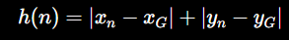

For example if :
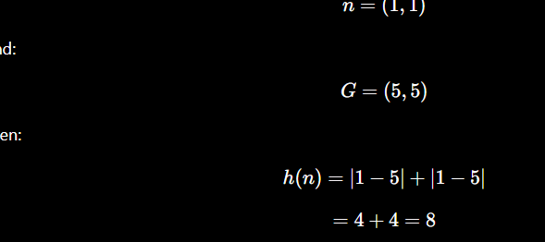
Step 4: Robot moves:
A possible initial movement is:
S → (1,2) → (1,3)
At each location, the robot observes its surroundings.

Step 5: New obstacle discovered:
Suppose the robot planned:
S → A → B → C → G
but when it reaches B, it discovers that C is blocked.
The robot performs:
Obstacle detected
↓
Mark C as blocked
↓
Update internal map
↓
Generate alternative moves
↓
Calculate new costs
↓
Select best available move
↓
Continue
For example:
C ✕
/
S → A → B
\
D → E → G
The robot changes from: B C
to: B D

Step 6: Final route:
The robot may eventually obtain:
The important point is that the route was replanned after discovering the obstacle.

Step 7: Online vs Offline:
Feature | Online Search | Offline Search
Complete map initially | No | Yes
Discovers obstacles | During execution | Before execution
Replanning | Yes | Usually unnecessary
Adaptability | High | Lower
Suitable for this robot | Yes | Less suitable

Conclusion:
Online search is appropriate because the robot does not initially know the complete warehouse environment. It observes, acts, learns and replans.

Complexity: depends on the number of discovered cells; grid search is typically around with a priority queue.

Q3. University Examination Scheduling — CSP
This is the question where the PDF provides all required numerical information. It has six examinations, four slots, six student-conflict constraints, and three halls.
Step 1: Variables
X={E1,E2,E3,E4,E5,E6}
Step 2: Domains
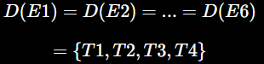
Step 3: Constraints
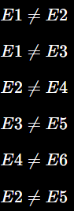
Step 4: Initial domains:
Exam | Domain
E1 | T1,T2,T3,T4
E2 | T1,T2,T3,T4
E3 | T1,T2,T3,T4
E4 | T1,T2,T3,T4
E5 | T1,T2,T3,T4
E6 | T1,T2,T3,T4

Step 5: MRV selection
All variables initially have four values.
Use conflict degree as a tie-breaker.
E2 has the highest number of conflicts, so:
E2=T1​
Forward checking:
- E1 removes T1
- E4 removes T1
- E5 removes T1
Exam | Domain
E1 | T2,T3,T4
E2 | T1
E3 | T1,T2,T3,T4
E4 | T2,T3,T4
E5 | T2,T3,T4
E6 | T1,T2,T3,T4

Step 6: E1
Choose:
Because E1 conflicts with E3:
is removed from E3.
Exam | Domain
E1 | T2
E2 | T1
E3 | T1,T3,T4
E4 | T2,T3,T4
E5 | T2,T3,T4
E6 | T1,T2,T3,T4

Step 7: E3
Choose: E3 = T1
E3 conflicts with E5, so T1 is removed from E5.
Exam | Domain
E1 | T2
E2 | T1
E3 | T1
E4 | T2,T3,T4
E5 | T2,T3,T4
E6 | T1,T2,T3,T4

Step 8: E4
Choose: E4 = T2
E4 conflicts with E6, so remove T2 from E6.
Exam | Domain
E1 | T2
E2 | T1
E3 | T1
E4 | T2
E5 | T2,T3,T4
E6 | T1,T3,T4

Step 9: E5
Choose: E5 = T3
There is no conflict between E5 and E6.

Step 10: E6
Choose: E6 = T3
E6 conflicts only with E4, which is at T2.

Final Timetable:
Time | Examinations
T1 | E2, E3
T2 | E1, E4
T3 | E5, E6
T4 | —

Hall Allocation:
The PDF gives capacities of 120, 90 and 60 students for Halls A, B and C respectively.
Time | Hall A | Hall B | Hall C
T1 | E3 – 70 | E2 – 80 | —
T2 | E1 – 100 | — | E4 – 60
T3 | — | E5 – 90 | E6 – 50
Every examination fits its assigned hall.

Finalanswer:
This satisfies both the conflict and capacity constraints.

Q4. Game-Playing AI — Minimax & Alpha-Beta
The objective is to find the best move for the MAX player using Minimax and then reduce unnecessary calculations using Alpha-Beta pruning.

Step 1: Evaluate MAX nodes
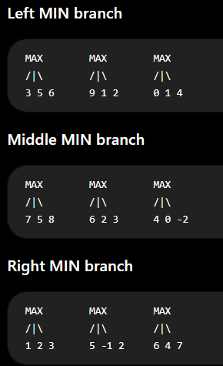
Therefore:
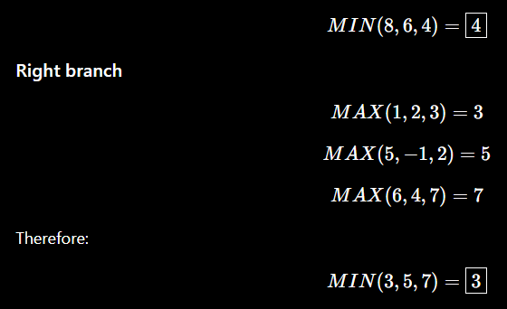

Step 2: Root MAX Decision
The three branch values are:
Branch | Value
Left | 4
Middle | 4
Right | 3
Therefore:

Final Minimax Answer:
There is a tie between Left and Middle. Using left-to-right selection:
Step 3: Alpha-Beta Pruning
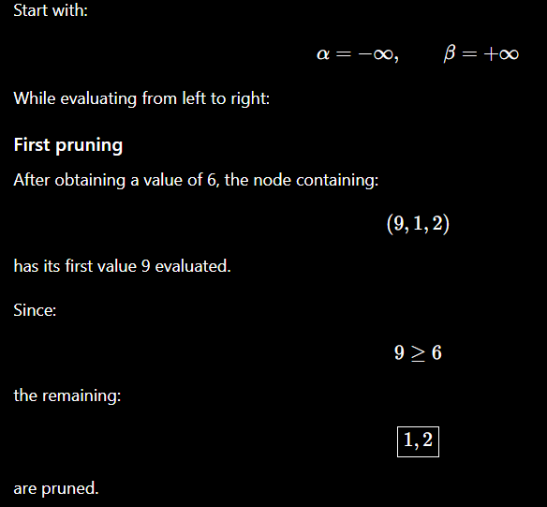
Second Purning :
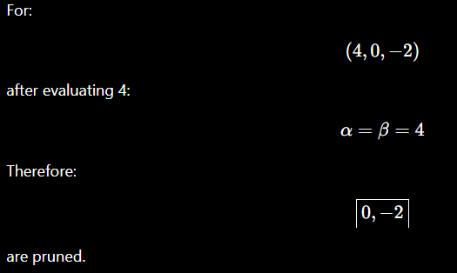

Third purning:

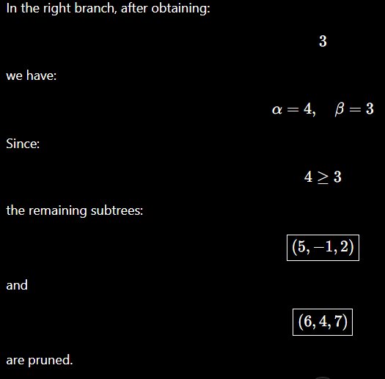

RESULT:
Minimum Value: 4
Best Move: Left
Alpha-Beta gives the same result while reducing the number of nodes evaluated.

Q5. Delivery Route Optimization Using Hill Climbing
1. Problem Statement:
A logistics company wants to minimize the total distance travelled by a delivery vehicle while visiting customers.
The problem provides:
- An initial route.
- Several neighboring routes.
- The cost/distance of each route.
- Information about the best neighbor after selecting S5.

2. Given Routes:
The PDF provides the following neighboring solutions:
Solution | Route | Cost
S1 | D → A → C → B → E → D | 26 km
S2 | D → B → A → C → E → D | 30 km
S3 | D → A → B → E → C → D | 24 km
S4 | D → E → C → B → A → D | 27 km
S5 | D → A → E → B → C → D | 23 km
S6 | D → C → B → A → E → D | 29 km
The question additionally states that from S5, the best neighboring solution has cost 22 km, and that all neighbors of that 22 km solution have cost at least 22 km.

3. Step 1 — Define the Objective:
This is a minimization problem.
Therefore:
The objective function is:
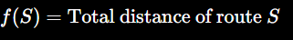
Hill Climbing tries to minimize:
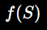

4. Step 2 — Select the Best Initial Neighbor:
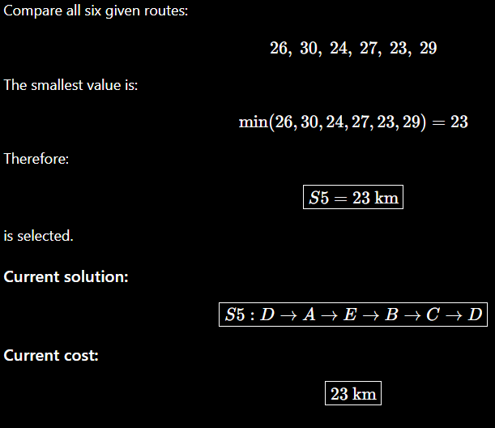
5. Step 3 — Generate Neighbors of S5:
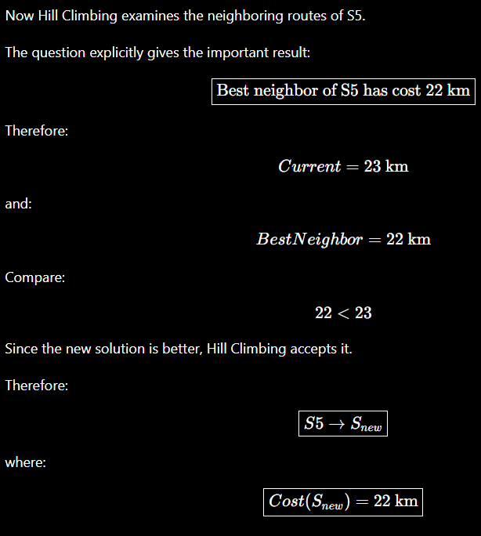

6. Step 4 — Update the Current Solution:
The current solution is now the newly discovered 22 km route.
The search becomes:
Current Solution
S5
23 km
↓
Better Neighbor
22 km
↓
Current Solution
22 km
So the current best cost is: 22 km

7. Step 5 — Check the Neighbors of the 22 km Solution:
The question states:
From that solution, all neighbors have cost ≥ 22 km.
Therefore:
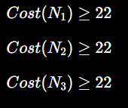
and so on.
There is no neighbor with cost less than 22 km.
For example, conceptually:
Neighbor | Cost | Better?
N1 | ≥22 | No
N2 | ≥22 | No
N3 | ≥22 | No
N4 | ≥22 | No
Since Hill Climbing is minimizing the distance, it cannot improve further.
Therefore: STOP

8. Complete Hill-Climbing Execution
The complete practical execution is:
START
↓
Examine S1, S2, S3,
S4, S5 and S6
↓
Select lowest cost
↓
S5 = 23 km
↓
Examine S5 neighbours
↓
Best neighbour = 22 km
↓
22 < 23 → ACCEPT
↓
Examine 22 km neighbours
↓
All neighbours ≥ 22 km
↓
No improvement
↓
STOP

9. Hill-Climbing Trace Table:
Iteration | Current Solution | Current Cost | Best Neighbor | Decision
0 | Given solutions | — | S5 = 23 km | Select S5
1 | S5 | 23 km | 22 km | Move to 22 km
2 | 22 km solution | 22 km | All ≥22 km | Stop
Therefore:
10. Why Does Hill Climbing Stop?
Hill Climbing stops when there is no neighboring solution that improves the current solution.
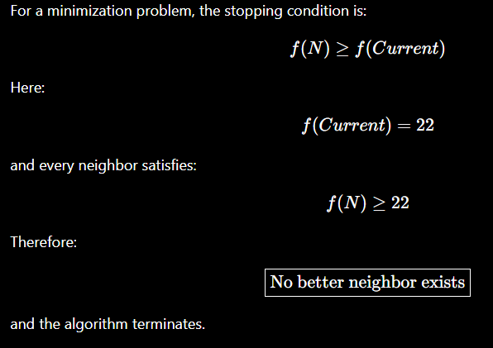
11. Is the 22 km Solution a Global Optimum?
We cannot conclude that 22 km is a global optimum from the Hill-Climbing information alone.
It is guaranteed only that no neighboring solution is better.
Therefore, it is a: Local Optimum
A global optimum would require proving that no route anywhere in the complete search space has a cost lower than 22 km.
Hill Climbing does not perform this complete search.

12. How Can We Escape the Local Optimum?
A good solution is Random-Restart Hill Climbing.
Procedure:
- Start with a different random route.
- Apply Hill Climbing.
- Continue until a local optimum is reached.
- Record its cost.
- Restart from another route.
- Compare all final solutions.
- Select the route with the lowest cost.
Example:
Random Start 1
↓
Hill Climbing
↓
22 km

Random Start 2
↓
Hill Climbing
↓
20 km

Random Start 3
↓
Hill Climbing
↓
24 km
Then:
So the 20 km solution would be preferred if it were actually found.
Other techniques that can escape local optima include:
and randomized search.

13. Final Answer
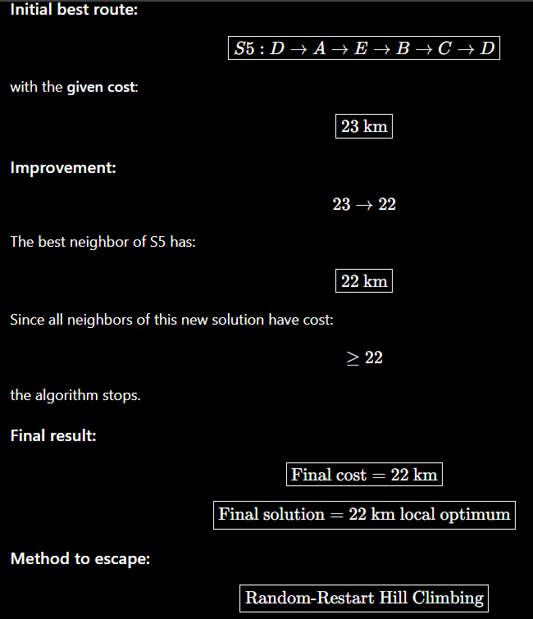

EVALUATION RUBRICS

Criteria | Weightage  (%) | Excellent (Full Marks) | Good | Average | Poor
CSP Problem  Formulation | 20% | 4% – Clearly defines all variables, domains, and problem objectives correctly. | 3% – Defines most variables and domains with minor errors. | 2% – Partial formulation with some missing components. | 0–1% –  Incorrect or incomplete formulation.
Constraint  Identification  &  Representatio n | 20% | 4% –  Accurately  identifies all student-confli ct and hall-capacity constraints and represents them correctly. | 3% –  Identifies most constraints with minor errors. | 2% –  Identifies some  constraints but misses important relationships. | 0–1% –  Constraints are largely incorrect or missing.
Application of  Backtracking,  MRV &  Forward  Checking | 30% | 6% –  Correctly applies  Backtracking,  MRV, and  Forward  Checking with clear and logical steps. | 4.5% – Applies the techniques correctly with minor mistakes. | 3% – Partial application with unclear or inconsistent steps. | 0–1.5% –  Incorrect or inappropriate application of  CSP  techniques.
Step-by-Step  Execution &  Domain  Updates | 20% | 4% – Provides a complete, logical execution trace and correctly updates domains after every assignment. | 3% – Mostly correct execution with minor gaps. | 2% – Provides limited steps with some incorrect domain updates. | 0–1% –  Incomplete or incorrect execution.
Final  Timetable,  Accuracy &  Justification | 10% | 2% – Produces a valid conflict-free timetable satisfying all constraints and capacity requirements with clear justification. | 1.5% – Valid timetable with minor errors in justification. | 1% – Partially valid timetable with some  constraint violations. | 0–0.5% – Invalid or missing timetable.

